**To fix the timeout error in shap plot:**

if shap_check == "true":  
 @after_this_request  
 def plot_shap(response):  
 @response.call_on_close  
 def process_after_request():  
 print("long_running_task ", img_src)  
  
 def f(X):  
 # return best_model.predict(X).flatten()  
 # print("++++++++++++++++++++++++")  
 result = []  
 for item in X:  
 prob = user_training_model.predict_proba(item.reshape(1, len(predset[0])))  
 # print(prob)  
 # print(prob[0][0])  
 result.append(prob[0][0])  
 print(np.array(result))  
 # the reason why we have 5 results is because we use kmeans to shrink the x_cv(background dataset) dataset to only 5 samples  
 # [0.4565038 0.3262849 0.3953898 0.23958007 0.3785722]  
  
 print(type(result))  
 return np.array(result)  
  
 # shap.kmeans(data, K) to summarize the background as K samples, in our case it transfer  
 X_train_summary = shap.kmeans(X_CV, 1)  
 print(X_train_summary)  
 # < shap.utils._legacy.DenseData object at 0x0000024682E412B0 >  
 print("111111111111111111111111111111111111111")  
 explainer = shap.KernelExplainer(f, X_train_summary)  
 print("222222222222222222222222222222222222222")  
 shap_values = explainer.shap_values(np.array([category_list]))  
 print("333333333333333333333333333333333333333")  
 print(shap_values)  
 print(explainer.expected_value)  
 plt.clf()  
 # shap.waterfall_plot(shap.Explanation(values=shap_values, base_values=explainer.expected_value, data=np.array([category_list]),feature_names=X_columns))  
 shap.waterfall_plot(shap.Explanation(values=shap_values[0], base_values=explainer.expected_value,  
 data=np.array([category_list])[0], feature_names=X_columns))  
  
 if os.path.exists(img_src):  
 os.remove(img_src)  
 if os.path.exists(img_src):  
 print("png exist")  
 else:  
 print("png does not exist")  
 print(img_src)  
 plt.savefig(img_src)  
 plt.clf()  
 return response

I use @response.call_on_close to plot shap in the backend after the function return the probability and shap image path. And then in the frontend i let the website wait for 2 minutes for the completion of plot. Therefore, it prevents the timeout error of server side.

The result: the shap plot can now be shown not only in localhost but also in aws environment.

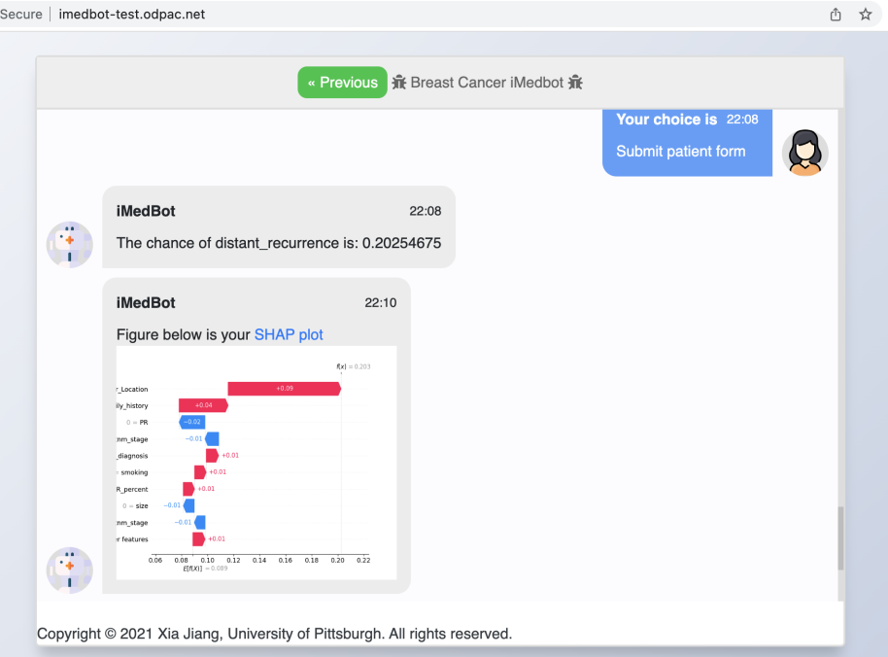

Error handling of training and dataset in the backend:

@application.route("/Examdataset", methods=['GET', 'POST'])  
def get_model_Examdataset():  
 if request.method == "POST":  
 datasetname = request.form.get('name')  
 print("data set name is ", datasetname)  
 try:  
 validation_auc,img_src = train_mode(datasetname)  
 return {"auc":str(validation_auc),"src":str(img_src)}  
 except Exception as e:  
 print(e)  
 return {"auc":"error","src":str(e)}

I catch the error in the training process and if there is an error it can return the error type to frontend and show it to users.

The result:

When uploading data-00.200.0-2.txt as dataset, it failed last time and now the system can catch error when training.

